Test Case: tc001_SPX_Dev5_Crear_Solicitud_Articulo_Almacen
Step 1 - Enter username and password and click to button Enter : Credentials Entered
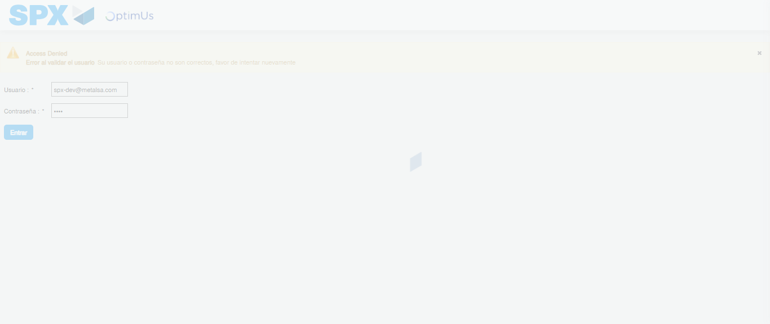Image file-name: QC_Testing-tc001_SPX_Dev5_Crear_Solicitud_Articulo_Almacen-1787861721445

Step 2 - Select to UEN and Access to Request for a New Inventory Item : UEN Correctly selected and Correct access
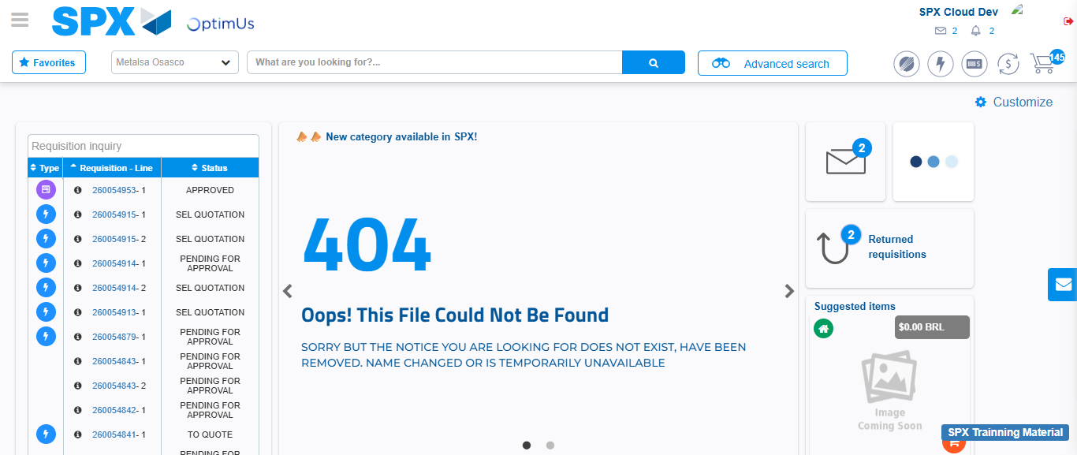Image file-name: QC_Testing-tc001_SPX_Dev5_Crear_Solicitud_Articulo_Almacen-1787861766701

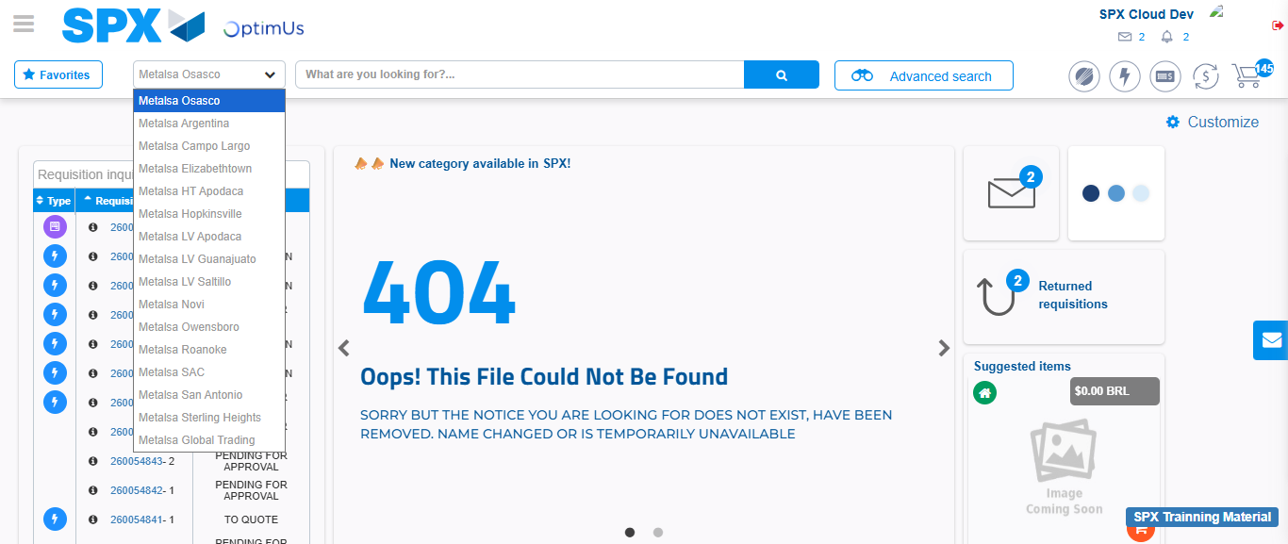Image file-name: QC_Testing-tc001_SPX_Dev5_Crear_Solicitud_Articulo_Almacen-1787861767228

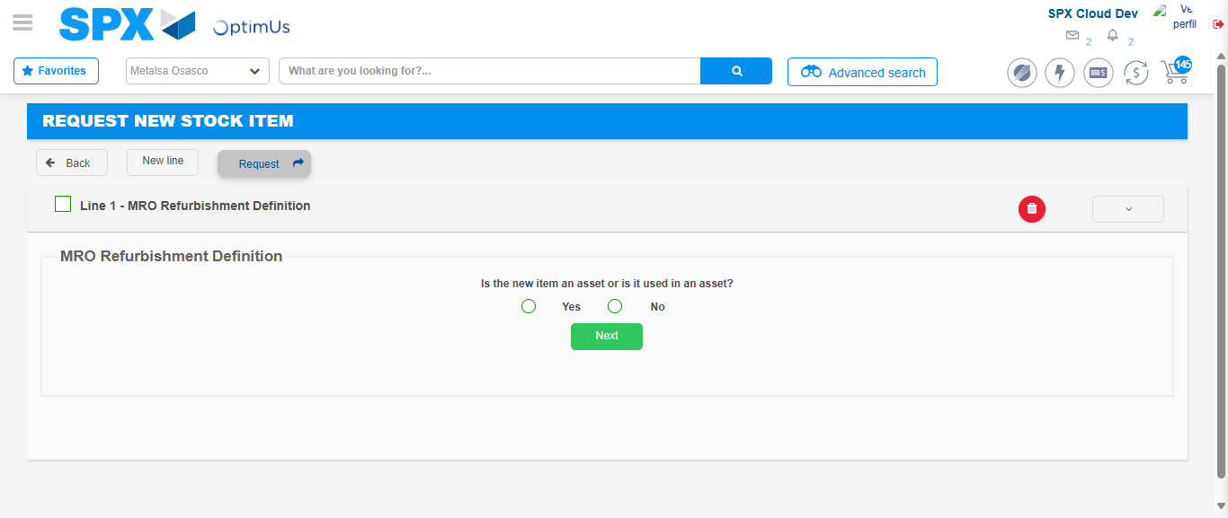Image file-name: QC_Testing-tc001_SPX_Dev5_Crear_Solicitud_Articulo_Almacen-1787861781099

Step 3 - Select options first section : Options seleted correctly
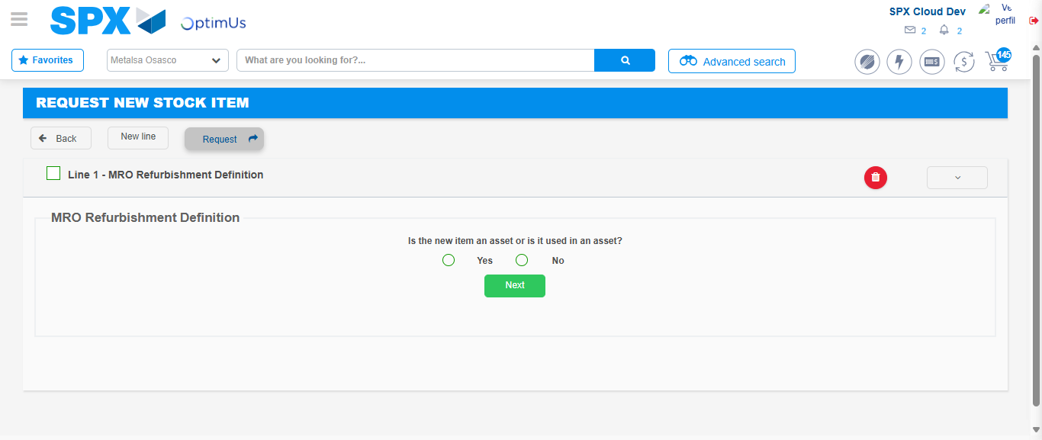Image file-name: QC_Testing-tc001_SPX_Dev5_Crear_Solicitud_Articulo_Almacen-1787861781357

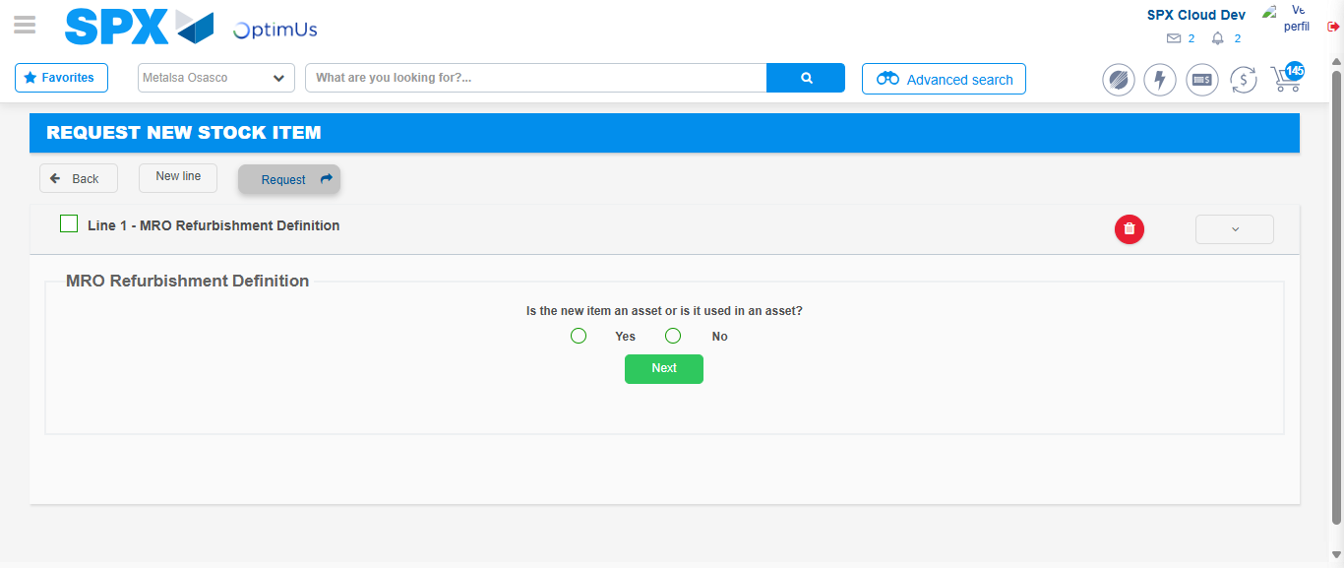Image file-name: QC_Testing-tc001_SPX_Dev5_Crear_Solicitud_Articulo_Almacen-1787861781566

Step 4 - Select options section location and position: Options seleted correctly
Image file-name: QC_Testing-tc001_SPX_Dev5_Crear_Solicitud_Articulo_Almacen-1787861781357

Image file-name: QC_Testing-tc001_SPX_Dev5_Crear_Solicitud_Articulo_Almacen-1787861781566

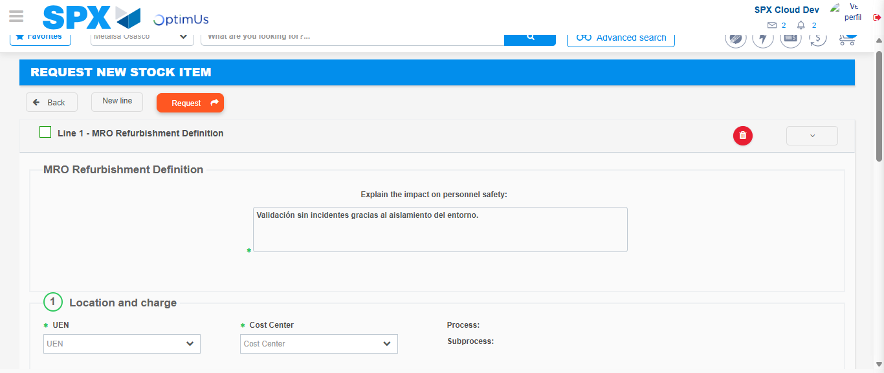Image file-name: QC_Testing-tc001_SPX_Dev5_Crear_Solicitud_Articulo_Almacen-1787861787469

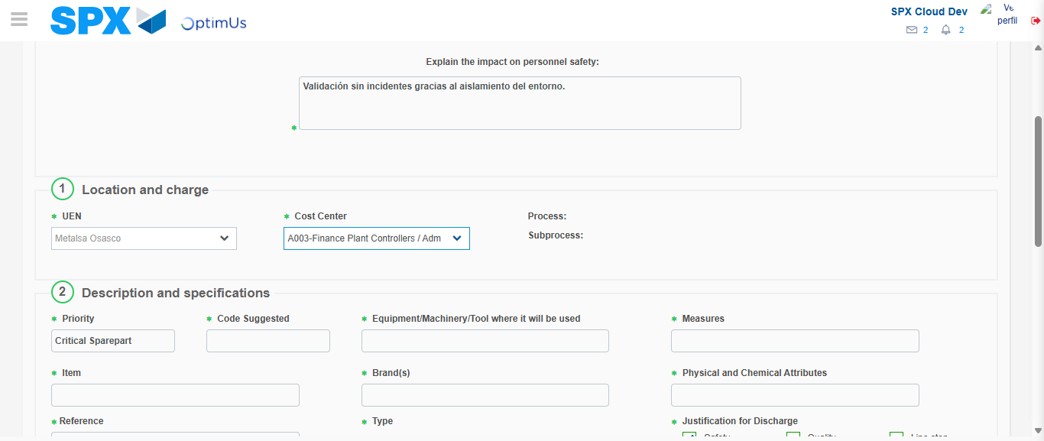Image file-name: QC_Testing-tc001_SPX_Dev5_Crear_Solicitud_Articulo_Almacen-1787861789860

Step 7 - Return to Main Page SPX : Return to Main Page SPX
Image file-name: QC_Testing-tc001_SPX_Dev5_Crear_Solicitud_Articulo_Almacen-1787861766701

Image file-name: QC_Testing-tc001_SPX_Dev5_Crear_Solicitud_Articulo_Almacen-1787861767228

Image file-name: QC_Testing-tc001_SPX_Dev5_Crear_Solicitud_Articulo_Almacen-1787861781099

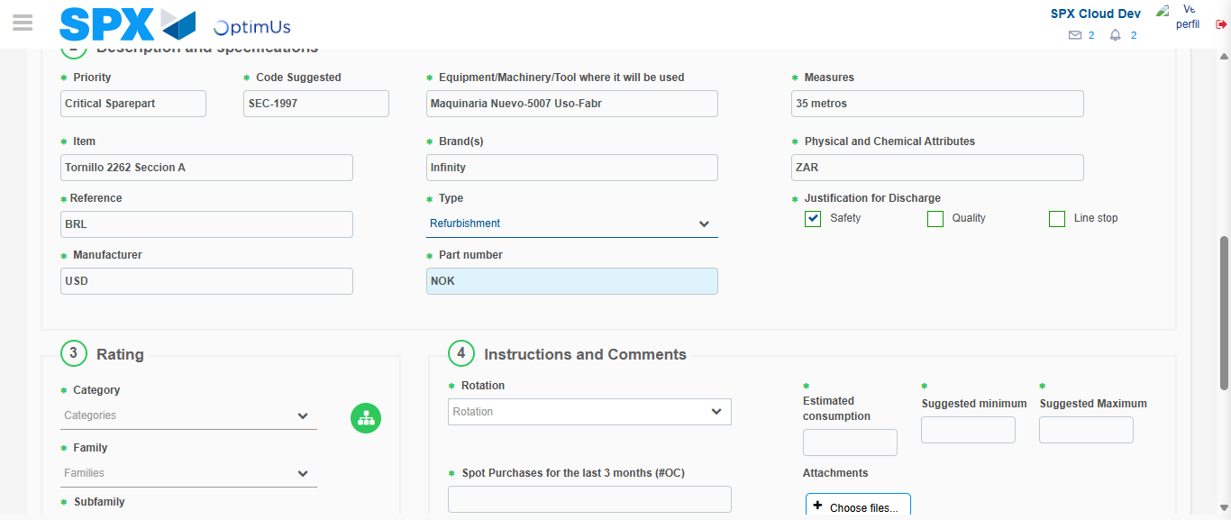Image file-name: QC_Testing-tc001_SPX_Dev5_Crear_Solicitud_Articulo_Almacen-1787861793081

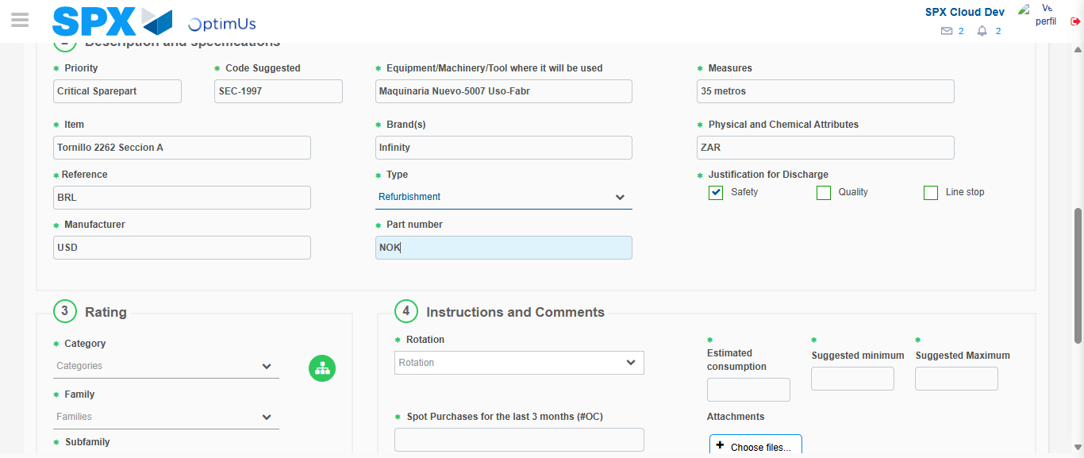Image file-name: QC_Testing-tc001_SPX_Dev5_Crear_Solicitud_Articulo_Almacen-1787861793244

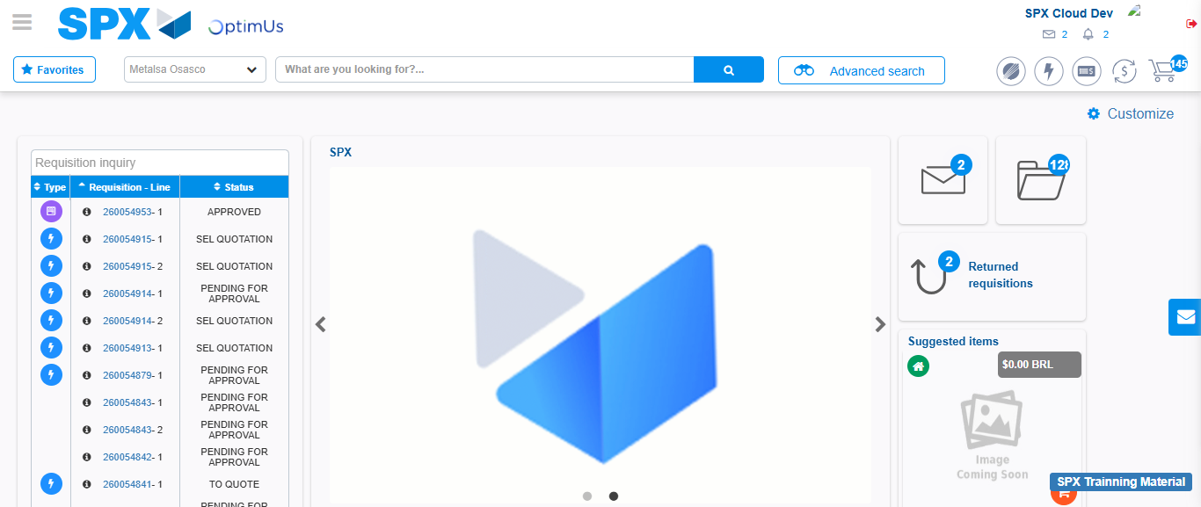Image file-name: QC_Testing-tc001_SPX_Dev5_Crear_Solicitud_Articulo_Almacen-1787861814272

Step 8 - Log Out : Log Out SPX
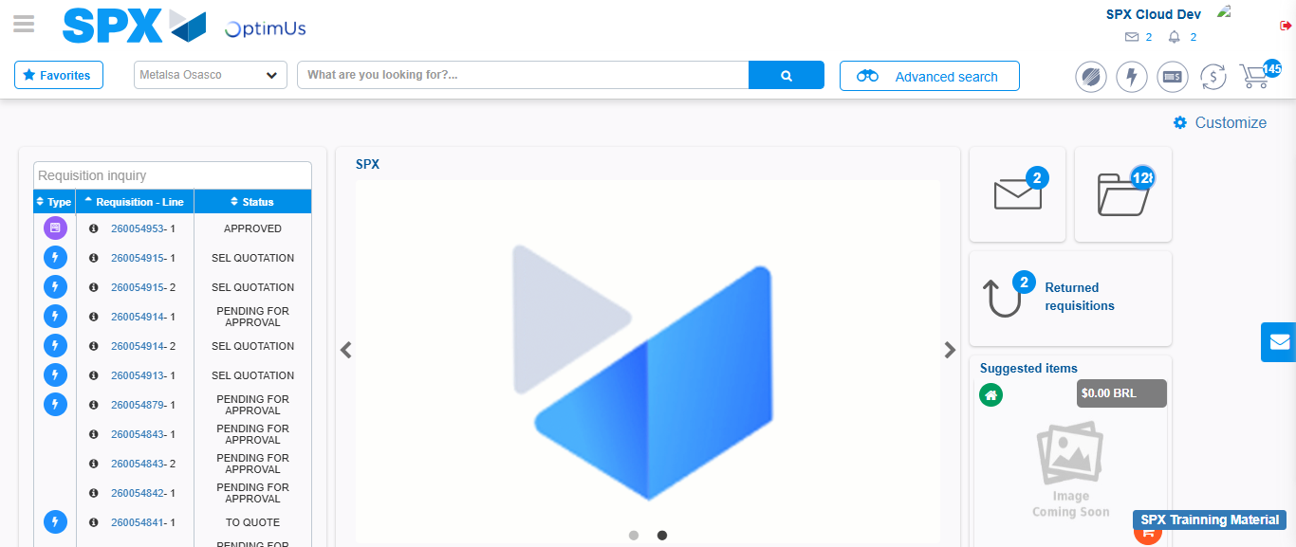Image file-name: QC_Testing-tc001_SPX_Dev5_Crear_Solicitud_Articulo_Almacen-1787861814521

